Assignment 1

Ajesh Vijayaragavan

M.S Computer Science - CS825

Assignment 1

R16: Processing delays, Transmission delays, Propagation delays and queuing delays are the delay components. Queuing delays are variable and rest of the delay components mentioned above are constant.

R22: A layer can perform error control, flow control, segmentation and reassembly, multiplexing and connection setup. Yes, these tasks can be duplicated at different layers. For example, error control is often provided at more than one layer.

P6:

1. dprop m/s seconds.
2. dtrans L/R seconds
3. dendHtoHend (m/s G L/R) seconds.
4. The bit is just leaving Host A.
5. The first bit is in the link and has not reached Host B.
6. The first bit has reached Host B.
7. Want

m $\overline{T}$ (L/R)s $\overline{T}$ (120/56’.103)*F2.5’ F 536 km.

P7:

To generate a packet, it takes 56B / 64kbps = 7 msec

The transition takes 56B / 2Mbps = 0.224 msec.

Propagation delay is 10 msec.

The total delay is 7 msec + 0.224 msec + 10 msec = 17.224 msec.

P18:

The command should be given as traceroute <website address> in linux command prompt and tracer <website address> in windows command prompt.

An example solution:

Traceroutes between San Jose Computer Center and [www.usnh.edu](http://www.usnh.edu)

1. The average (mean) of the round-trip delays at each of the three hours is 71.18 ms, 71.38 ms and

71.55 ms respectively. The standard deviations are 0.075 ms, 0.21 ms, 0.05 ms respectively.

1. In this example, the traceroutes have 12routes in the path at each of the three hours. No, the paths didn’t change during any of the hours.
2. Traceroute packets passed through four ISP networks from source to destination. Yes, in this experiment the largest delays occurred ar peering interfaces between adjacent ISPs.

Traceroutes from [www.ba.co.uk](http://www.ba.co.uk) (United Kingdom) to [www.iit.edu](http://www.iit.edu) (USA).

1. The average round-trip delays at each of the three hours are 87.09 ms, 86.35 ms and 86.48 ms respectively. The standard deviations are 0.53 ms, 0.18 ms, 0.23 ms respectively. In this example, there are 11 routers in the path at each of the three hours. No, the paths didn’t change during any of the hours. Traceroute packets passed three ISP networks from source to destination. Yes, in this experiment the largest delays occurred at peering interfaces between adjacent ISPs.

P33:

Time at which the 1st packet is received at the destination = ((S + 80)/R) * 3 seconds. After this, one packet is received at destination every (S+80)/R second. Thus delay in sending the whole file = delay (((S+80)/R) * 3) + ((F/S)-1) * ((S+80)/R) = ((S+80)/R) * ((F/S)+2)

To calculate the value of S which leads to the minimum delay,

(d/ds) delay = 0 => S = $\sqrt{40F}$

cs725-f17-a1-ping-n

5.a)

Minimum Latency: 12.6 ms

Maximum Latency: 1657 ms

Mean Latency: 37.9781 ms

Median Latency: 31.5 ms

Standard Deviation of the Latency: 86.1103 ms

b) Packet loss rate: 52.8 %

c) Average and maximum length of the period when packets were not delivered

(pings at 5 per second):

Average : 0.423 seconds

Maximum length : 3.2 seconds

d) Graph distribution of ping latencies



e) Most significant network behavior difference between two experiments. Mention the 1 different aspect?

The most significant network behavior that I observed is high standard deviation for set ping-n. I also noticed that ping latencies don’t have much differences and looks moderate as observed from the graphical representation.

f) Is there Periodicity in network latency?

Yes, I see that network latency recur at regular interval.

Snippet of the code:

Implemented in python, Assignment1.py will process input from cs725-f17-a1-ping-n and cs725-f17-a1-ping-p

And stores in array dynamically after converting to int and float. Thereby using the values to calculate measures. It also imports re, statistics, csv to work on input files.

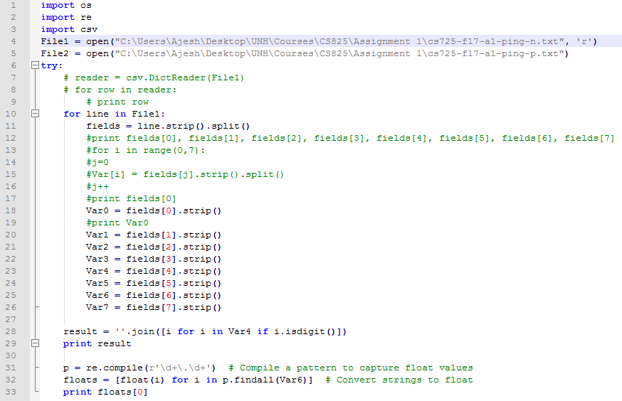

cs725-f17-a1-ping-p

1.a)

Minimum Latency: 18.9 ms

Maximum Latency: 112 ms

Mean Latency: 31.902 ms

Median Latency: 24.6 ms

Standard Deviation of the Latency: 16.4147 ms

b) Packet loss rate: 49.9 %

c) Average and maximum length of the period when packets were not delivered

(pings at 5 per second):

Average: 0.447

Maximum length : 2.2

d) Graph distribution of ping latencies



e) Most significant network behavior difference between two experiments. Mention the 1 different aspect?

The most significant network behavior that I observed is lower standard deviation for set ping-p when compared with set ping-n. Additionally, noticed that ping latencies have hike and abnormal differences as observed from the graphical representation.

f) Is there Periodicity in network latency?

No, from the graph, I see that network latency mostly doesn’t recur at regular interval.